Project Design Phase Problem–SolutionFitTemplate

|  |  |
| --- | --- |
| Date | 26June2025 |
| TeamID | LTVIP2025TMID33776 |
| ProjectName | Pattern sense:ClassifyingFabricPatternsusingDeep Learning |
| MaximumMarks | 2Marks |

# Problem–SolutionFitTemplate:

In the textile industry, accurately identifying and classifying fabric patterns is a major challenge. Manualclassificationistime-consuming,error-prone,andinefficient—especiallywhendealingwitha wide range of traditional and modern designs. Existing automated solutions often lack precision and do not generalize well across fabric types.

# Whofacestheproblem?

* Fabricdesigners
* Qualitycontrolteams
* Textilemanufacturersandproductionsupervisors

# Currentscenario(withoutyoursolution):

* Relianceonhumaninspection,whichissubjectiveandinconsistent
* Limiteduseofautomationoroutdatedmodelswithpooraccuracy
* Lackofconfidencescoresortransparentclassification
* Difficultyinprocessinglargevolumesoffabricsamplesquickly

# Purpose:

☑Solvecomplexfabricclassificationproblemsinawaythatfitstheneedsoftextileindustry professionals.

☑Succeedfasterbytappingintodeeplearning’sabilitytohandlelargepatterndatasetsand variations.

☑Sharpenyourmodel’saccuracyandimproveusabilitywithclearlabelsandconfidencescores.

☑Increaseefficiencyinproductionandqualitychecksbyautomatingrepetitivepatternrecognition tasks.

☑Understandtheexistingclassificationchallengesinordertobuildareliable,scalablesolution

# Template:

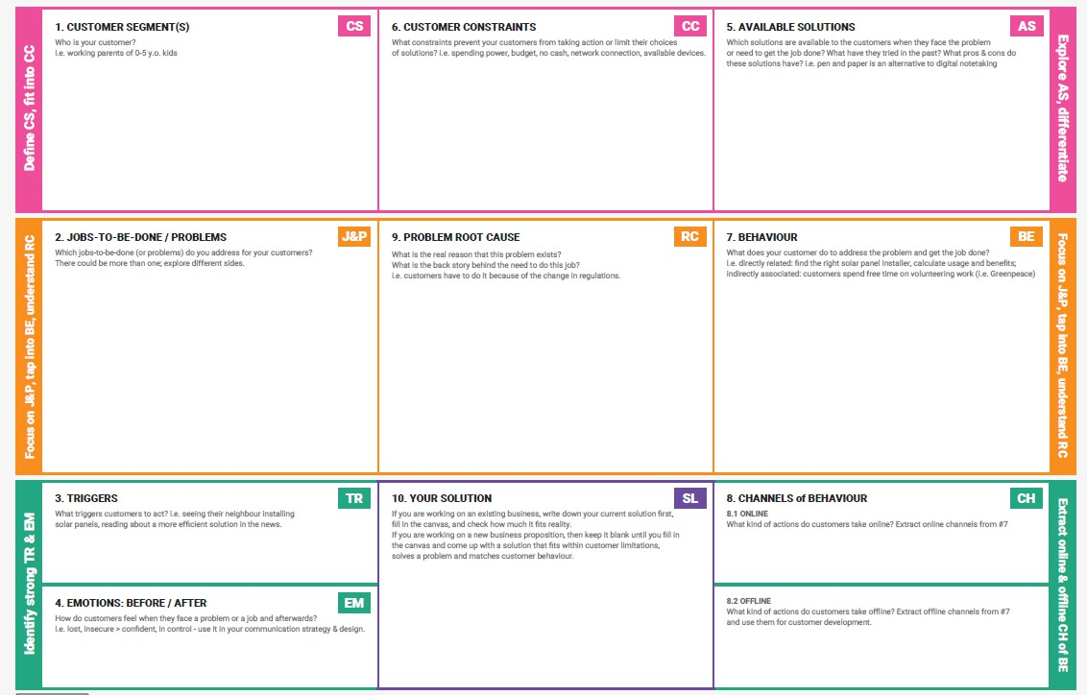

References:

1. <https://www.ideahackers.network/problem-solution-fit-canvas/>
2. [https://medium.com/@epicantus/problem-solution-fit-canvas-aa3dd59cb4fe](https://medium.com/%40epicantus/problem-solution-fit-canvas-aa3dd59cb4fe)